FYP-203 FIGMA DESIGN

Splash Screen



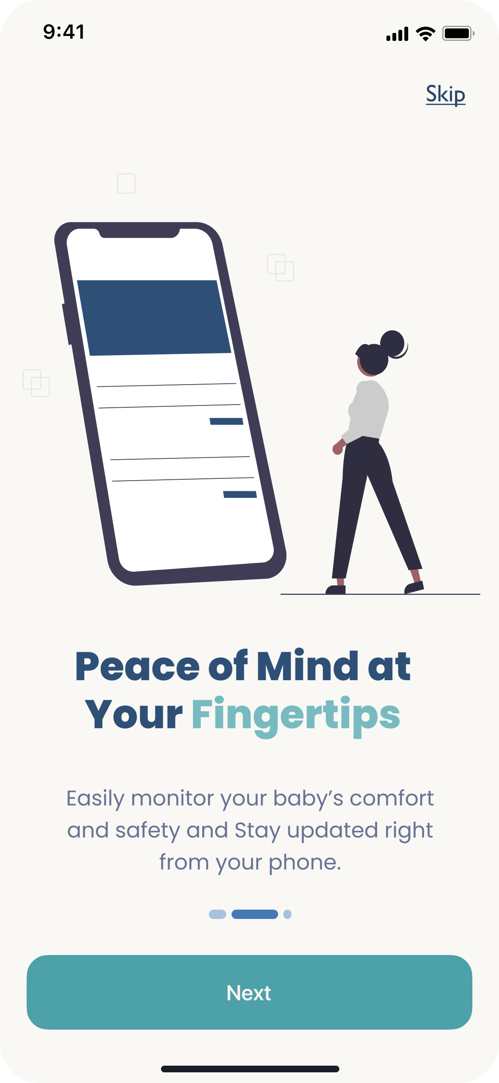

Sign-up and Sign-in screen

Home Screen

Live stream screen

Notifications screen

Setting screen

